File Folder Bridge

| **Subject:** *Physics, Math*  **Related Subjects:** *Civil Engineering* | **Grade Level(s):** *8th*  **Length of Lesson:** *60–75 minutes* | **Type:** Project  **Keywords:** *Paper Engineering, Compression, Tension* |
| --- | --- | --- |

# Lesson Overview

In this lesson, students will design and construct a bridge made from a file folder that spans a set distance and can support the most weight possible in a cup placed on top. Students will apply concepts of structural design and engineering, focusing on material use and geometry.

# Lesson Focus

How can we design a strong, lightweight bridge using only a file folder and glue to span a fixed distance and hold the most weight possible?

| Lesson Objective(s) | By the end of this lesson, students will be able to:   1. Apply principles of structural engineering such as tension, compression, and load distribution. 2. Explore the effects of shapes (chords, tubes) in building strong structures. 3. Design, build, test, and evaluate their own paper bridge models. 4. Use rulers and scales to ensure accuracy in measurements and fairness in competition. |
| --- | --- |

# Lesson Timing

| 5 minutes | Introduce the Lesson |
| --- | --- |
| 10 minutes | Planning and sketching designs |
| 30 minutes | Construction of bridges |
| 15 minutes | Weight testing and results |
| 10 minutes | Group reflection and discussion |

| Materials | * File folder * Carpenter’s Wood glue * Paint brush * Cup * Rocks for weights * Rulers * Scale |
| --- | --- |
| Instructor Prep | Step 1: Set Up Testing Station  * Place two cinder blocks or thick books 15 cm apart to act as the testing platform. * Ensure the station allows for a cup to be placed in the center of the bridge.  Step 2: Prepare Testing Materials  * Presort weights into manageable quantities for quick testing (e.g., small bags of rocks or washers). * Test your own sample bridge to ensure glue drying time and materials are adequate. |
| Related Resources | * [Designing and Building File-Folder Bridges](https://www.bridgecontest.org/resources/file-folder-bridges/) |

# Lesson Plan

## Introduction

Introduce students to the real-world application of bridge design and challenge them to build a paper bridge using a file folder that can support the most weight.

1. Ask Relatable Questions:
   1. Have you ever walked or driven over a bridge?
   2. What do you think keeps a bridge from collapsing?
   3. Why do some bridges have arches, trusses, or beams?
2. Lead into Concepts:
   1. Explain that bridges use force distribution and geometry to support weight. Today, students will become civil engineers and test how design affects strength using only a file folder and glue.
3. Show Real-World Examples:
   1. Use images or quick slides showing types of bridges (beam, arch, suspension).
   2. Ask:
      1. What’s different about how these bridges look?
      2. Why might certain shapes be stronger?

## Procedure

1. Bridge must have a length of at least 16 cm and no greater than 17 cm, and must be able to rest on the two cinder blocks of the testing apparatus (cinder blocks will be 15 cm apart).

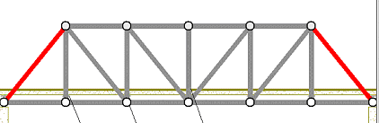

1. Bridge must have a width of 6cm
2. Bridge must have a section on top of the bridge in the center to support the cup.
3. Students sketch their bridge designs on paper. Ask them to:
   * Identify how they’ll meet the length and width requirements.
   * Plan how they’ll create support under the center of the bridge where the cup will sit.
4. Using rulers and scissors:
   * Cut the file folder to the appropriate length (16–17 cm) and width (6 cm).
   * Use folds (accordion, tubes, layered strips) to reinforce the structure.
   * Plan for a **center platform**—a stable, flat section to hold the cup.
5. Assemble the Bridge:
   * Glue pieces as needed, using clamps or light pressure (rocks) to hold sections together while they dry
   * Avoid excessive glue—use a paintbrush to apply evenly and allow quicker drying.
6. Test the Bridge:
   * Place the finished bridge across the two cinder blocks (15 cm apart).
   * Gently place the cup at the center support area.
   * Add rocks one at a time to the cup until the bridge collapses.
   * Record the total weight held before failure.

Things to Consider:

| Testing of bridge | Chords and Tubes |
| --- | --- |
|  |  |
| I-beams are illegal | |

## Wrap-up

1. Ask:
   1. What parts of your design helped your bridge stay strong?
   2. Did any part fail first? Why?
   3. If you could rebuild it, what would you do differently?
   4. How did understanding geometry or distribution of forces help your design?
2. Engineering is about **design, testing, and improvement**.
3. Even simple materials can create strong structures with the right design.
4. Understanding **forces, tension, and compression** is crucial in building.

Cleanup considerations

* Clean all glue residue from tables and tools.
* Dispose of or recycle used materials properly.

# Lesson Background for Teachers

## Suggested Real-World STEM Connections



* [**Dr. Tiera Guinn Fletcher**](https://en.wikipedia.org/wiki/Tiera_Guinn_Fletcher) – *Structural Engineer at Boeing*
  + Played a key role in designing the Space Launch System (SLS) for NASA.
  + Advocate for young women of color in engineering.
* Bridge Design in Civil Engineering: Engineers design bridges that balance material use, cost, and load-bearing capability for highways, railways, and pedestrian crossings.
* Disaster-Resistant Infrastructure: Engineers must account for natural forces like earthquakes, floods, and wind in bridge construction.
* Sustainable Engineering: Use of recycled materials and optimization of design to reduce environmental impact.
* Urban Planning: Bridges play a crucial role in connecting communities and reducing travel time and fuel usage.

## Lesson Variations and Options

* Advanced Challenge: Introduce truss design concepts and allow use of additional materials like string or toothpicks to simulate reinforcement.
* Digital Simulation: Use free online tools like [Bridge Designer](https://www.bridgedesigner.org/) to let students test designs virtually before building.
* Themed Bridges: Have students design bridges for specific scenarios (e.g., earthquake zones, pedestrian use, eco-friendly material constraints).

## Explanation

Structural Engineering Principles

* **Forces**: Bridges must handle compression (pushing forces) and tension (pulling forces). Poor designs may buckle or snap under pressure.
* **Load Distribution**: The bridge must transfer weight from the central load (the cup with rocks) to the ends resting on the cinder blocks. Using curves, arches, or reinforced folds helps.
* **Material Properties**: File folders (cardstock) can be folded into shapes like tubes or box beams to greatly increase strength without more material.
* **Center of Mass and Stability**: Ensuring the load is balanced and placed in the center ensures even stress distribution and prevents tipping or twisting.

Engineering Design Process

1. ***Ask****: What problem are we solving?*
2. ***Imagine****: Brainstorm ideas and consider real-world bridge types.*
3. ***Plan****: Sketch designs, choose materials, and predict performance.*
4. ***Create****: Build the bridge.*
5. ***Test****: Place the cup and add weights.*
6. ***Improve****: Reflect, redesign, and optimize the structure.*

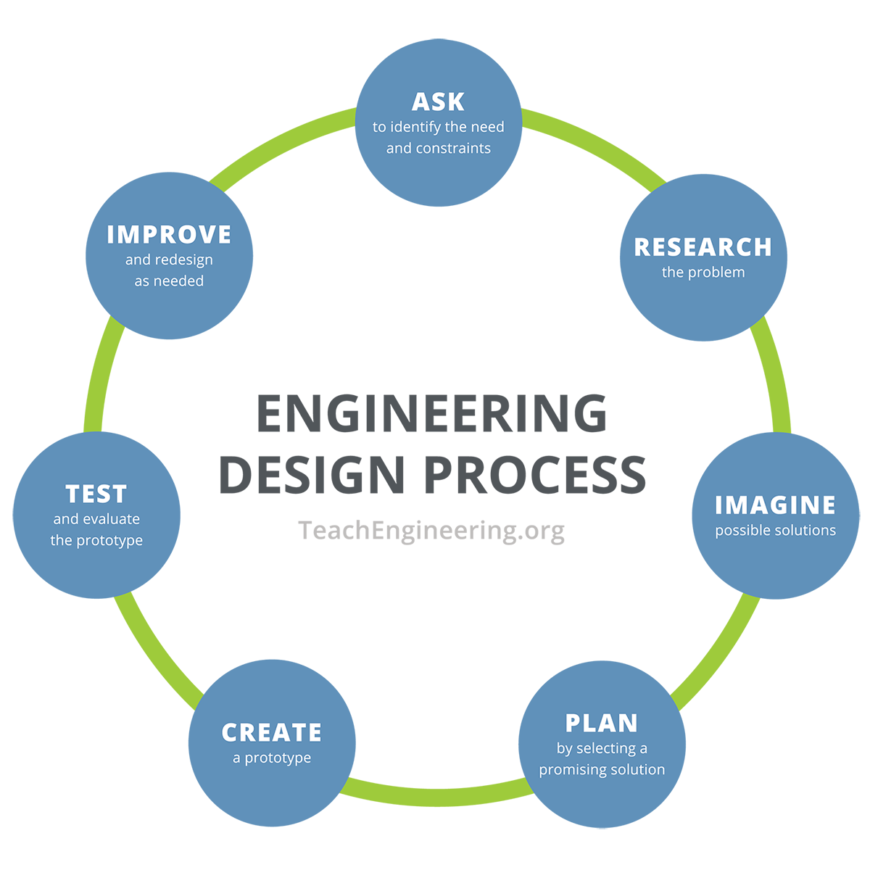

## Key Concepts and Vocabulary

* **Compression:** A force that pushes or squeezes material together.
* **Tension:** A force that pulls material apart.
* **Load-bearing:** The ability of a structure to support weight.
* **Chords:** Structural elements that span across and resist bending.
* **Truss:** A framework of beams that form triangles to provide support.

## Safety Notes

* Handle glue carefully. Use only a small amount with the paintbrush provided. Do not touch your face or eyes while using glue. Wash your hands afterward.
* Use scissors properly. Cut away from your body and keep fingers clear of the blades. Always walk, never run, with scissors.
* No I-beams allowed. Follow the design rules and work within safe limits. Ask questions if unsure about what’s allowed.
* During testing, stay alert. Keep your face and hands away from the bridge when weight is being added.